User’s Manual

Interrobang

Interactive Puzzle Game

# **‽**

# Installation of Interrobang

How to install Interrobang. (Include screenshots)

## Prerequisites

In order to run Interrobang, the user must have access to an x86_64 based architecture computer with at least 4Gb of RAM, a 1.5Ghz or better processor, and enough room on the harddrive to hold up to 5Gb of content. The system must also be able to run file with a .exe extension. Most modern windows platforms can run these files with no problems. If you have a Mac or Linux based system, look for possible solutions online for running .exe files.

## Download the Game from Github

1. Follow this link to the Github repository of Interrobang: <https://github.com/JohnHardy5/Interrobang>
2. Download the contents of the repo by clicking the button labeled “Clone or Download” and selecting download zip.
3. The repository will then be downloaded as zip folder to your downloads directory.
4. Open the downloads directory using the file management software for your operating system and unzip the folder in location that you want the game to run in.
5. You have successfully downloaded Interrobang! Note that the only files you actually need to run the game are contained in the “Build” folder, all other files can be deleted if you do not wish to modify the game yourself.

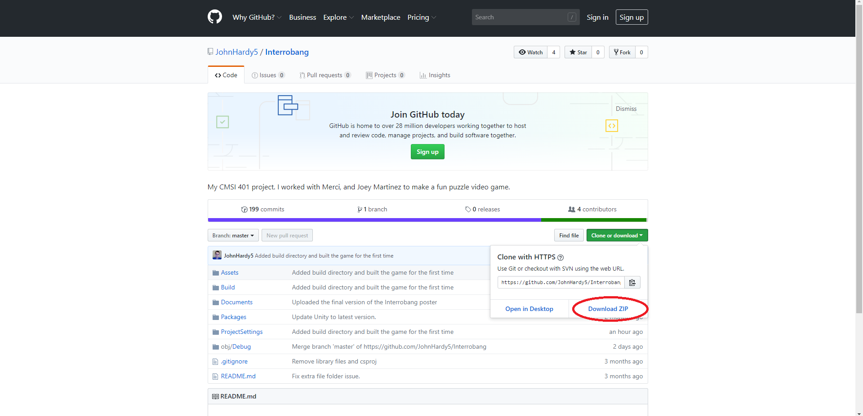

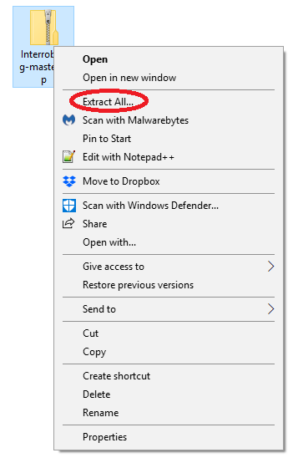

# Running Interrobang

1. Using your file management software, navigate your filesystem to the directory that contains the unzipped Interrobang folder.
2. Open the Interrobang folder.
3. Open the Build folder.
4. You should see a bunch of files that are used as libraries to run the game. Notice the file named “Interrobang.exe”.
5. Run the file by double-clicking on it or by selecting it and choosing the option to run the file.
6. Interrobang will start running on your system.
7. If everything works correctly, you will be presented with a window that gives you options for keyboard input layouts, resolution and windowed vs. non-windowed mode.
8. Click “play!” when you are ready to play the game.

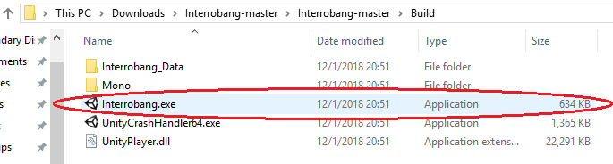

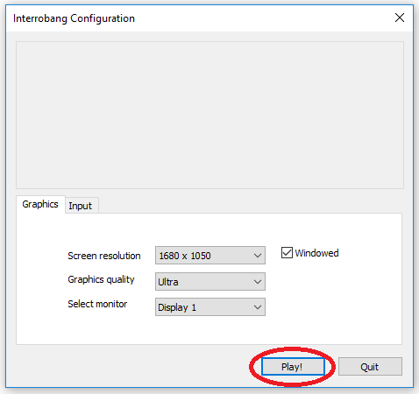

# Stopping Interrobang

1. If the game is in fullscreen mode, use alt + tab in windows to exit the window. Hover over the game from the task bar and click the red “X” in the corner of the miniature icon.
2. For Mac and Linux systems, use command + tab to exit the window. Right click on the icon for the game and select “close window”.
3. If the game is NOT in fullscreen mode, use the same key combinations to exit the game and click the red “X” at the upper right hand portion of the window.

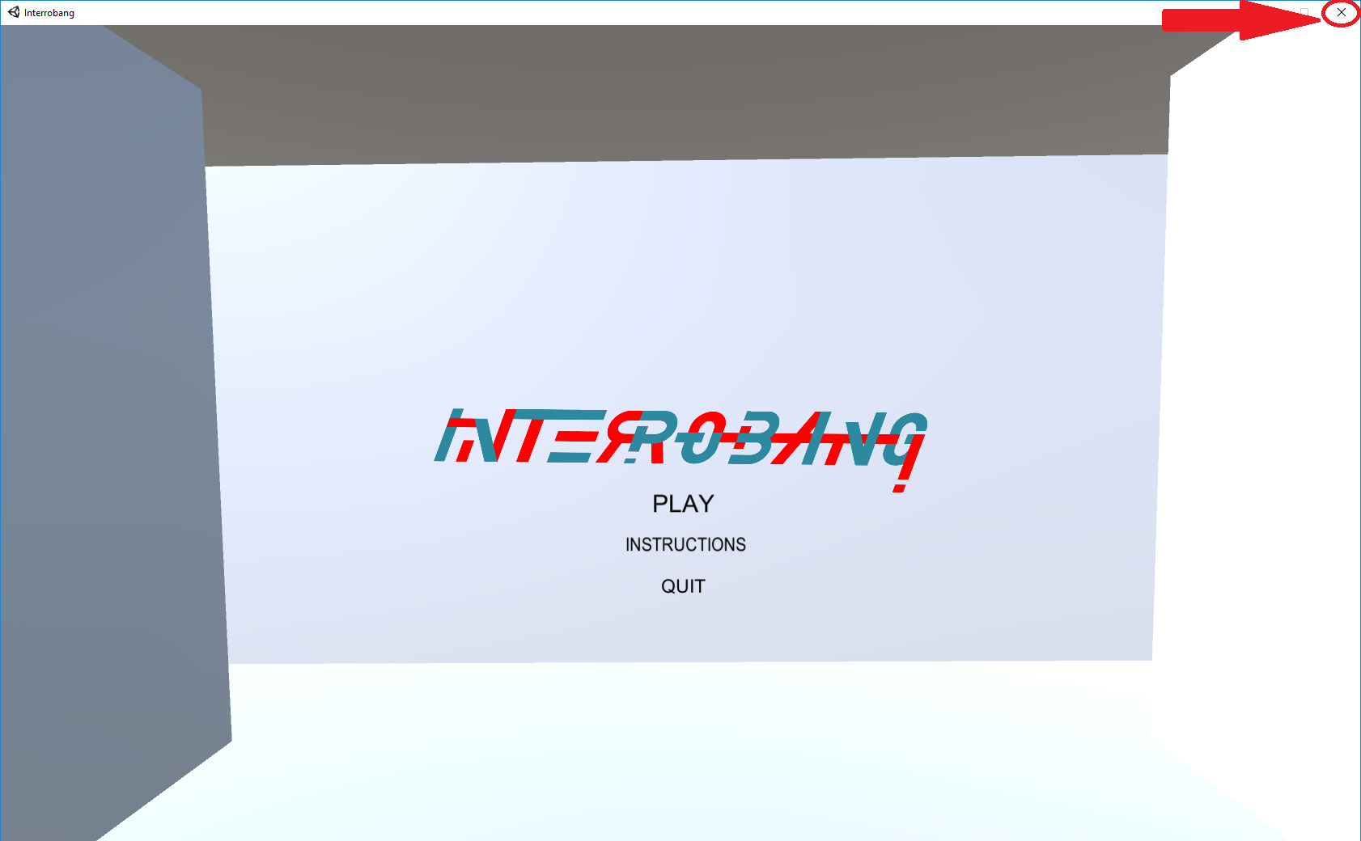

# Uninstallation of Interrobang

1. Navigate to the directory in you filesystem that contains the “Interrobang” folder.
2. Select the Interrobang folder without opening it.
3. Click the “delete” key on your keyboard.
4. If you are presented with a confirmation window, select the affirmative option to delete the folder.

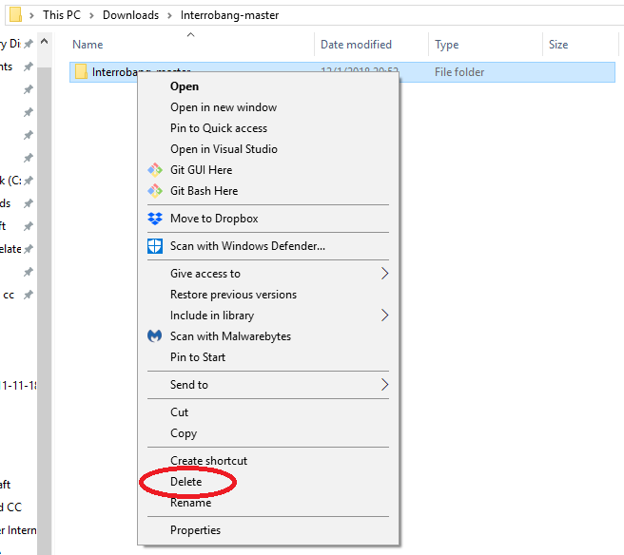

# How to Play Interrobang

## Overview

For anyone who has played any sort of 3D game before with a keyboard and mouse, learning how to play Interrobang will come quickly to them. Those with little to no exposure to such video games, learning how to play Interrobang will be very difficult as the game requires the user to have significant hand-eye coordination to play well.

## Keyboard Manipulation

The default keyboard layout for Interrobang is as follows:

* The “W” key is used to move the player **forward** in the direction the camera is pointed.
* The “A” key is used to move the player **left** of the direction the camera is pointed.
* The “S” key is used to move the player **backwards** of the direction the camera is pointed.
* The “D” key is used to move the player **right** of the direction the camera is pointed.
* The “Shift” key is use to increase the player’s movement speed while the user holds the button down. The moment that the key is release, the player’s speed is reduce. Note that this will still work as normal even while the player is traveling through the air.
* The “Space bar” is use to jump the player. The player cannot jump while they are in the air.

**NOTE:** The default keyboard layout for Interrobang can be changed using the initial start-up window presented to the user before playing the game.

## Mouse Manipulation

The mouse is used to manipulate the player’s camera and controls what the user sees on the screen.

* Moving the mouse *forward* will move the camera so that it is pointed **upward**.
* Moving the mouse *left* will move the camera so that it is pointed **left**.
* Moving the mouse *backward* will move the camera so that it is pointed **downward**.
* Moving the mouse *right* will move the camera so that it is pointed **right**.

**NOTE**: The camera is designed so that the player cannot look behind themselves without turning their entire body. In other words, the player is not able to look over their shoulder or tilt their head completely backwards. If the camera is moved too far upward or downward, it will reach a point where it will no longer move any further in that direction.

## Interactions with the Level

There is a limited amount of interaction that the player can do with the level. The three main things that the player can do are:

* Jump onto Platforms: There are multiple types of platforms such as static non-angled platforms, static angled platforms, and moving platforms. All static platforms will hold the player in midair regardless of angle. All moving platforms will carry the player along its designated path of movement.
* Press Buttons: If the player stands over a button in the level, the button will be depressed and will trigger an event somewhere in the level. Note that pressing the button multiple times may or may not create special interactions with the world.
* Hit Spikes: If the player touches a spike at any point during the game, they will “die” and will be teleported back to the most recent spawn location that they reached in the world. Note that spawn locations are hidden in hallways and are invisible to the player. **NOTE:** there is a known bug in the game where the player becomes “invincible” to spikes and does not die when they touch them. If this happens to while you are playing the game, it is recommended to restart the game in order to get the best experience out of the game.

# Troubleshooting

## Installation Problems

* If you are having difficulties with unzipping the game, consider googling a step-by-step guide on how to unzip a file from your downloads directory.
* If you are having difficulties downloading the game, ensure that you have an active internet connection and that your firewall is not blocking your access to Github.com. Note that some systems have limitations on them that do not let you download content from the web.

## Problems Running the Game

* The most common reason that someone is unable to run Interrobang is that their operating system does not support .exe files (common in Mac OS and Linux based computers). It is recommended to run the game on a Windows based computer in order to run the .exe file for the game.
* If the game does not start properly, ensure that all of the files in the build folder on the github repository match the files in the build directory in your filesystem. It is not uncommon for us to push patches to fix bugs in the game that require the user to redownload the game.

## Problems Stopping the Game

* Sometimes, if the computer runs out of memory or processing power to run the game it will “freeze” and stop responding to inputs given by the user. If this happens to you and the game continues to not respond after a couple of minutes, try using the task manager or process manager in your system to manually shut down the program. In windows this can be done with ctr + alt + del.
* The current version of the game does not have an in-game menu for the user to use to exit the game. For this reason, the game must be closed manually using the steps highlighted above. For some this may not be a simple task. Another method of closing the game is to use alt + tab or cmd + tab to exit the window and then right click on the game’s icon to get an options menu. Select the option the closes the game/window.

## Problems Uninstalling the Game

* Note that this problem only occurs if the user unzipped the Interrobang folder into a directory that is protected from deletion operations (i.e. unzipping into the root directory of the C: drive). To delete the game files in this situation, the user will need to login to the computer as an administrator, navigate to that directory using the file management software, and delete the folder using administrator privileges.

## Problems Playing the Game

* Keep in mind that this game is still very underdeveloped and may contain significant bugs in it. If you encounter one of these bugs, it is recommended that you restart the game in order to get the best experience possible. Please report these bugs to any of the game developers in the contact information section of this document.
* A currently well known bug in the game prevents the player from dying when they touch spikes in the level. If this occurs while you are playing the game, please restart the game as spike interaction is one of the main features of the game. Any other issues should be reported to one of the game developers listed below.

# Contact Information

Lead Software Designer: Joey Martinez ([joeymichaelmartinez@gmail.com](mailto:joeymichaelmartinez@gmail.com))

Lead Software Developer: John Hardy ([jhardy5@lion.lmu.edu](mailto:jhardy5@lion.lmu.edu))

Lead Art Designer: Merci Magallenes ([mmagall5@lion.lmu.edu](mailto:mmagall5@lion.lmu.edu))